Ultimate Goal of learning English

1) Speaking – Input >>> Listening – S.A.U.R. ®
- Speak - Speak up / Read aloud
- Analyze - Steps of analyzing a sentence
- Understand
- Reuse
* Speak up!!!!! [21 times ➔ 66 times ➔ Habit!!!!] *
2) Writing – input >>> Reading – V.S.O.P ®
- Verb - [‘verb’ with tense ➔ finite verb / limitations – tense / time zones]
- Subject - [doer of the ‘verb’ – ‘V’ ]
- O. - [Other information ➔ Object ‘O’ / Subject Complement ‘S.C.’]
- P. - [Pronunciation / Phrase / Prepositional Phrases / Punctuation]

* Read aloud!!!!! [21 times ➔ 66 times ➔ Habit!!!!] *
3) Objective – Nature & Sentence Structure [4 4 2] ®

- 4 - Parts of speech ➔ Noun / Verb / adjective / adverb
- 4 - Learning process ➔ word ➔ phrase ➔ clause ➔ sentence
Phrase - groups of words - without Verb <tense>
Clause - groups of words - with Verb <tense>
- 2 - Core parts of a sentence ➔ S Lv SC. / Subject Complement
S Vi. (intransitive verb)
S Vt O. / Object (transitive verb)

* Verb – Linking Verb [Lv] - No Action / Being - Less important / weak tone
* Verb – Action [vi [I] / vt [N] - Brain & Body - More important / strong tone

Sentence Structure
- Subject + Linking Verb + Subject Complement (S + Lv + S.C.)
- Subject + Verb intransitive (S + Vi + …..)
- Subject + Verb transitive + Object (S + Vt + O)
- Subject + Verb transitive + Indirect Object + Direct Object (S + Vt + IO + DO)
- Subject + Verb + Preposition + Object [object of preposition] (S + Vi + Prep + O)
Section 1 - What is a complete sentence? Are the following complete sentences?

http://theplate.nationalgeographic.com/2015/04/27/when-it-comes-to-wine-glasses-size-and-shape-matter/?utm_source=Facebook&utm_medium=Social&utm_content=link_fbp20150427plate-wineglass&utm_campaign=Content&sf8835713=1 – National Geographic
https://www.youtube.com/watch?v=gJgmvw7W-r4&list=PLB5045F604D9524D0&index=2 – TDC [0:42]

- Correct / Wrong - Size and shape.
- Correct / Wrong - Wine glasses.
- Correct / Wrong - Comes to doing business.
(she / it / he → missing the subject)
(You) Open the door. (correct → You/I → can be omitted.)
Order / Request!!! → imperative sentence
( I ) Hope you like it. (correct)
Trainers-to-be
- Correct / Wrong - When it coming to doing business.
No Tense (is / am / are / was / were / will be +ing) ➔ continuous
- Correct / Wrong - When it comes to wine glasses.
(key subject → no ‘obstacles’ – WH / H / If / although / because – Dependent clause)
- Correct / Wrong - Hong Kong is our cup of tea.
- Correct / Wrong - When it comes to wine glasses, size and shape matter. (v)
When it comes to = about are very important. (adj) ☹ weak
Verb (tense / time) verb (tense / time)
What’s the matter? What is the matter?
a/an/the + noun
The + noun (matter = case)
It doesn’t matter (v). ➔ It matters.
- Correct / Wrong - When it comes to doing business, Hong Kong is our cup of tea.
Abalone
Trainees => IPA → linking/elision/ structure
Trainers-to-be [Train the trainers] Abalone

Complete sentence – Core elements:
- Subject [S] (missing – Imperative sentence (NO subject) – order)
- Verb with tense [Time zone → past or present] [You / we / I – See you next week]
Now (at the moment) / in the future/ in the past
- Object [O]
- Subject Complement [SC]

Shallow / superficial ➔ simple(naïve)
➔ mental / knowledge (IQ)
Skin-deep ➔ Proverb
Beauty is only/but skin-deep.

Examples
- When it comes to wine glasses, size and shape matter. [11]
Subject [S] Verb (vi)
Make sentences:
A - favourite jobs - pay / promotion prospects / location / work conditions
When it comes to my favourite job, pay matters.
………………………………………, promotion prospects matter.
B - life mate - character / appearance / height / education qualifications
When it comes to (choosing) my life mate, character matters.
When it comes to choosing my life mate, character takes precedence over everything.

Beauty is only skin-deep.
One stone kills two birds
Mate - classmate / roommate / inmate – under the same roof
Partner - task / business
Companion - journey

- When it comes to doing business in China, Hong Kong is our cup of tea. [15] my favourite
Subject [S] Verb (Lv) Subject Complement [SC]
Make sentences:

A - doing sports - tennis / badminton / basketball / football
When it comes to doing sports, tennis is my favourite / my cup of tea. [my favourite]
B - favourite footballer - Messi / Kaka / Beckham / Ronaldo
When it comes to footballers, Beckham is my favourite.
football players

Section 2 – Sentence Structure: Circle the verb (with tense) of each sentence and Underline the subject

1) S.A.U.R. ➔ Speak / Analyze / Understand / Reuse or Rewrite or Repeat or Refer
2) V.S.O.P. ➔ Verb (tense) / Subject / Other info (Object / S.C.) / P ➔ Extra Parts [Prepositions + Nouns]

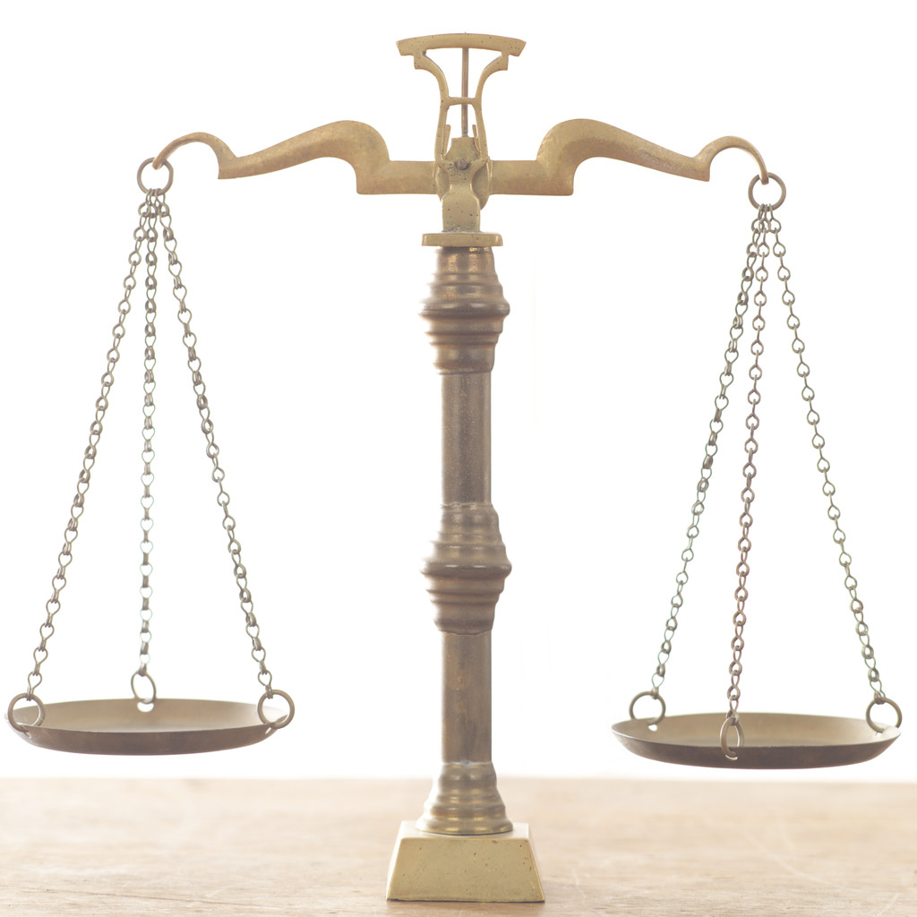
Part 1: Subject Lv Subject Complement
- The delay of the above order was due to the typhoon Haiyan.
Subject
Key Prep+noun (extra)
One of my friends are (wrong) a police officer.
One of my friends is a police officer.

- Vanguard Express was the first international air-express company to operate here. Operate in Hong Kong
TV network

Part 2: Subject Vi ➔ Speaking → VSOP
- Overdraft of current account occurs from time to time.(sometimes)
Subject Prep+noun (*extra) (* Prep+noun - extra)
Noun (adjective) (adverb → Verb)
Prepositions + noun
Traffic jams [C] occur from time to time in this district.
Traffic congestion [U] occurs from time to time
- The boy has progressed in his studies during the last few months.
Vi prep+noun (extra) (extra)

Part 3: Subject Vt Object
- We reserve the lawful right to demand you to pay for the losses.

- The sample will reach your main office tomorrow.

Part 4: Subject Vt IO indirect object / DO = direct object – must!
Extra (IO) MUST (O)
Him / her (tone)
- Her colleagues bought her a birthday cake.
Her colleagues bought a birthday cake for / to her.
☹
Buy sth for sb - only in situations (sb – long)
Buy sb sth - Native speaker (sb – short – him / her)
Pattern
Give sth to sb / offer sth to sb
Provide sth for sb

Go to the school → to ‘direction”
Look forward to their reply.
Send sth to sb.

- The mistake has caused us inconvenience and losses.
The mistake has caused inconvenience and losses to us. ☹

- (you) (Please) show me the money!!! ➔ tell me the truth
- (you) (Please) Show the money to me!!! ➔ tell the truth to me
http://en.wikipedia.org/wiki/Jerry_Maguire http://www.youtube.com/watch?v=FFrag8ll85w [0:45 / 1:26 / 1: 47 ….]

Part 5: Subject Vi Prep Object [Object of preposition]
- The Sales Manager will arrange for the down payment in no time.
at once
immediately
Arrange [vi/vt]
Arrange sth [vt]
Arrange for sth [vi +prep]
Switch on the computer (object of preposition)
Turn on the computer
Open the computer(laptop) (object)
Keep pace with the world

- I can’t concentrate on my work with all that noise.
- Concentrate (vi) on sth
- Focus (vi) on sth
- Keep my mind on sth
Honesty is the best policy.

Section 3 – Types of Verb

Part 1 - Linking Verb - Be ‘ = ‘ (is / am / are / were / was) [Lv]
- NO action at all [being / state / condition of the subject ‘S’] ➔ Subject Complement [SC]
- Weak tone ➔ only time zone (tense)
Examples of Subject Complement [SC] → Verbs [NO action at all]

Information about SC (Subject Complement)
1) name / noun - The man is her lover.
Subject Subject complement
2) adjective - The man is [be ➔ Lv] happy.
- The man looks [look ➔ Lv] happy.
- The man remains [remain ➔ Lv] happy.
3) adverb of place - The man was here.
- The man is down-stairs.
4) prepositional phrase - He is in a hurry.
Examples of Linking Verbs [Lv]crazy
Out of sight, out of mind → love story!!!!
**** Read between the lines
Understand the real meaning

- (v) Scratch the surface
- (v) beat about the bush
- (v) Get to the bottom of the subject
- (v) Read between the line
- (n) a hot potato
- (n) a couch potato
- (proverb) Beauty is only skin-deep
- (sentence) When it comes to doing business in China, Hong Kong is our cup of tea.

Patient (adj) / sincere – inner beauty
Tall / slim – outer beauty

- Be - fact / sure [is / am / are / was / were / will be / has been …]
- (adj) Look [Lv] / seem / appear - feelings [unsure] [personal feelings – subjective]
- (adj) Get / go [Lv] / become /come- process of change
- (adj) Stay / keep / remain - status / condition [the same]
- (adj) feel - feeling

Activity – Comparison on Linking Verbs – Define the nature.
- [Fact / Change] Sanjay was a tutor of Genius School in 2004.
- [Fact / Change] Sanjay became a trainee in Tiger Bank in 2005.
*In 1993, Rowling was a teacher. In 1996, she became a writer.
Proud of my son
- [Fact / Personal Feelings] Sanjay is arrogant. (adj. 傲慢的;自大的;自負的)
- [Fact / Personal Feelings] Sanjay looks arrogant.
- [Personal Feelings / Change] Sanjay became arrogant after he was promoted.
- [Fact / the same status] Sanjay remains arrogant. (is still - adverb)
The (y)outlook of the stock market remains uncertain.
The bullish outlook ☺ / view The bearish outlook ☹
➔ positive ➔ negative
Appearance / looks
- Hong Kong is [Lv] our cup of tea.
- Size and shape matter. [Action – vi]
- We must have [vt] the same outlook on life.
(outlook – view / opinion
Garbage in, garbage out.

http://www.ibtimes.co.uk/uk-house-prices-nationwide-2012-index-420165 Outlook for UK House Prices ‘remains uncertain’

Part 2 - Action Verb – done by Body or Brain

Fill in the blanks with the correct type of action verbs

- jog
- wave
- consider
- imagine
- watch
- decide
- eat
- draw
- smell
- kick
- plan
- hear
- write
- stand
- jump
- shake

Brain
decide | consider | imagine | plan

Body – Head or Organs
watch | eat | hear | Shake/smell

Body – Hands
draw | shake | wave | write

Body – Legs
Jump | stand | kick | jog

Taste is [Lv -weak] very important.
Taste matters. [Av – vi]
Action verb – more important & powerful
- vi / V [I] – without any nouns (No object) – intransitive verb / verb intransitive
- vt / V [T] V[N] – with nouns (with object) – transitive verb / verb transitive

vt 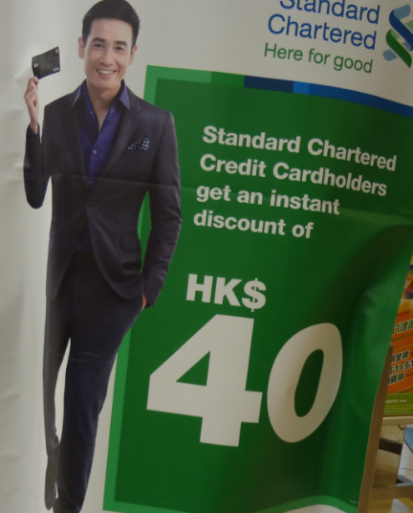 vi

Activity – Are the following sentences correct or wrong?

Eat (vi) (vt)
Everything is sky-high.

rise (vi) – no object / raise (vt) – object
Vi – no passive voice

- The sun rises [vi] in the east. [Wrong / Correct]
Preposition+noun ➔ extra
Look! (look – vi)
Look at that! [prep+noun]
- The management should raise [vt] the salary. [Wrong / Correct]
S vt O
- You have to rise [vi] the morale. [Wrong / Correct]
- The company is going to raise [vt] the price. [Wrong / Correct]

Increase (vi) (vt)
The price has increased. (vi)
I will increase the price.
(vt → subject – doer of ‘the verb’ increase)
Improve (vi) (vt)
My English has improved.
I have improved my English.

Raise + noun
Verb + noun ➔ phrases
Raise the salary / morale / standard / price
Raise a family / a child

arrive (vi) / reach (vt)

I couldn’t reach (vt) you. (contact)
I can be reached (adj) at 29992999. (NAmerica)➔ You can reach me at 29992999.
on 29992999 (UK)

- The goods have arrived the office. [Wrong / Correct]
Vi NO object
- The goods have reached the office. [Wrong / Correct]
Vt object
- Ivy arrived in Thailand yesterday (adv). [Wrong / Correct]
Extra – place extra – time
Preposition + noun (preposition ➔ in / at / on / for / of / by…)

- We have reached. (vt) [Wrong / Correct]

Complain (vi)
Complain to Kat Kat ➔ direction (solution – Kat - ☺
Complain about Kat Kat ➔ Kat Kat ☹ ➔ culprit (root-cause)

A turning point → pronunciation
Like

A - Do you like (vt) the actor?
- Yes, I do. (correct / wrong)
Short answers → Tense (do → present time zone)
- Yes, I like him. (correct / wrong)
- Yes, I like. (vt) (correct / wrong)

What are you doing (vt)? I am doing sth
I am working (vi). (I am working on the report)
I am doing (vt) the report.
Just do it. (do → (vt) / work (vi) / make (vt)
Action Verb+noun (information)
I am doing. (wrong – do - vt)
I am working. (correct – work – vi)

B - Have you sent (vt) the letter?
- Yes, I do. (correct / wrong)
Wrong tense
- Yes, I have sent. (correct / wrong)
vt ➔ Yes, I have sent it.
Yes, I’ve sent it.
- Yes, I have. (tense) (correct / wrong)
Do you have a ruler?
Yes, I have. (Wrong!!!)
Yes, I do. / Yes, I have a ruler.

Return [ipa] [vi] / [vt] [n]
Vi → eg.
Vt → eg.
N → e.g. Preposition + noun / a/an/the + noun

- I will return. (vi )
- I will return (vt) the sample on Monday.
- The return (noun) is not satisfactory.
Subject → noun

Run
- I run (vi ) in the park every morning.
- I run (vt ) a company.
- Let’s go for a run. ( noun) (walk / jog / swim / ride)

Preposition + Noun [prep+n ➔ extra]
A / an / the + noun
Put the theory into practice
Put sth into practice
Implement sth
Activity: Define the types of the underlined verbs ➔ vi / vt / Lv.

Walk
- He arose and walked ( vi ) to the window. (arise = stand up = get up)
- The mother walked (vt) the child out of the room.
Bring/accompany sb / Walk the dog /
Please walk the chairman onto the stage.
Stand
- I just can't stand ( vt) the cold. / the heat / the smell
Durian ➔ If you can’t stand the heat, you get out of the kitchen
- He stood (vt) the ladder against the wall.
Stand (vi)
Appear
- Herman appears (LV) happy (adj) every time I see him.
Every time when
Whenever / when
- Gradually a smile appeared ( vi) on her face.
Preposition+noun (extra)

Become
- This color becomes ( vt ) you. (old-fashioned ➔ suits)
This colour is suitable for you.
This colour suits you. (fits / matches)
Our fund fits you.
Radiance becomes you.
Slogan / appeal / strong tone – action verb (straight to the point)
- She became (Lv ) a famous writer.

Stay
- I hope the weather will stay (Lv) fine. (adj)
Read between the lines ➔ implies (weather → will be fine)

Will stay fine (now (fine) future (fine)’ Will be fine (now????? (bad)

Pronunciation → Positive language (No ‘not’) (NO!!!)
Don’t tolerate sth → show zero tolerance / no tolerance
I’m not interested in sth → I have zero / no interest in sth
- Free (free of charge) / worry-free / tax-free (duty-free)
- Yes No ? ➔ not -- Primary 1 and 2
- Rules ➔ Don’t run! – Primary 3 and 4
[Stop abusing ‘NOT’]
I don’t know. ➔ I have no idea / I have no clue.

- The government took no step to stay (vt ) the rise in prices.
Take action / step / measure / precaution

Keep
- Please keep ( Lv ) quiet.(adj)
- Mrs Chan keeps ( vt) my children when I shop. [US] http://dictionary.cambridge.org/dictionary/british/keep_1?topic=buying-and-selling
Shop-keeper do the shopping (➔ shop vi)
A keeper ➔ goal-keeper do the housework / chores [chair]
- Mary keeps (vt) a diary. (update)
Book-keeper → keep the book
Keep the stock / inventory

Come
- The door came ( Lv) open (adj) for no apparent reason. http://dictionary.cambridge.org/dictionary/british/come_5
The door is opened (action-passive) by Tom every day.

Open (adj – no obstacles) ➔ Open-door Policy
The store is open 24 hours. [24/7] [around the clock]
Rock round / around the clock
HK never sleeps.

- The announcement came (vi) at a bad time. [prep+noun ➔extra]
2012 – Time July 1 – Can Hong Kong people trust this man?
The bad news came at a bad time.
The scandal came at a bad time.

Go
- The milk went ( Lv) sour (adj). (became)
- We will go ( vi) to Shanghai by train.
Strike while the iron is hot.
Look
- She looks ( Lv ) happy (adj) all the time. 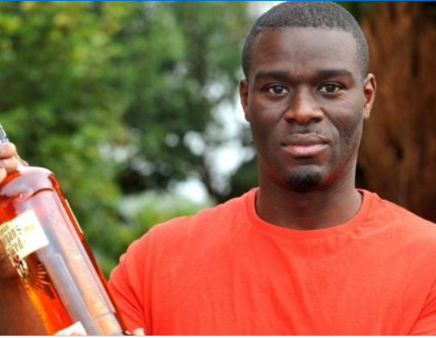
- The man doesn't look (vt ) his age. http://www.mirror.co.uk/news/uk-news/morrisons-asks-fifty-year-old-dad-id-2324193
Look (Lv) ➔ Oxford Dictionary
Jaw-dropping (adj) ➔ My jaw dropped
Honesty is the best policy.

Activity - Comparison on Structure [Linking Verb – Lv] be = [4 = 1+3] [1+3=4]

- Subject Linking V (be) Subject Complement
SC LV (be) = S
NO action
- Be – information / structure

Mindset → trainer-to-be
Attract
Pique sb’s interest / curiosity
Catch sb’s eye (shape/colour)
- start

Set 1
(correct / wrong) The best way to learn is to learn from the best.
(correct / wrong) To learn from the best is the best way to learn.
Set 2
(correct / wrong) "The best way to find yourself is to lose yourself in the service of others." – Mahatma Gandhi
(correct / wrong) To lose yourself in the service of others is the best way to find yourself.
http://www.allgreatquotes.com/top_ten_mahatma_gandhi_quotes.shtml

Set 3
(correct / wrong) Nothing is impossible.
(correct / wrong) Impossible is nothing. ➔ Pique sb’s interest / curiosity
http://www.goodreads.com/author/quotes/692403.Audrey_Hepburn

Observant (adj) – has an eagle eye
Stand in the shoes of native speakers

Set 4
(correct / wrong) You are stubborn.
(correct / wrong) Stubborn are you.
Set 5
(correct / wrong) The copies and the report are attached.(adj – passive)
Structure – weak → first part (too long)
(correct / wrong) Attached are the copies and the report.
Here are sth
There are sth…
Structure → better → first part (must be shorter)

Set 6
(correct / wrong) George Clooney was one of a number of protestors arrested Friday for storming the Sudanese Embassy during a demonstration in Washington, CNN reports.
(correct / wrong) Arrested alongside him were his father, Nick Clooney, Democratic U.S. Reps. Jim Moran of Virginia and
James McGovern of Massachusetts, NAACP president Ben Jealous and Martin Luther King III.
http://www.hollywoodreporter.com/news/george-clooney-arrested-sudan-embassy-protest-washington-dc-301114

apart from sb / as well as sb / alongside sb

Activity – Comparison on Action Verb [vi/vt] and Linking Verb [Lv]
Write down the types of verbs ➔ Action [Av] (vi/vt) OR Linking Verb [Lv]
No action  Subject LV Subject complement  S Lv information about the Subject  S =[be/fact] SC  4 = 1 + 3  ____________________________________________  - Suri is [Lv] = be the manager of IDP Company.  - Suri has remained /remains [Lv] vigilant (adj) after the 911 Incident. [keep a vigilant eye on sth] [at / on vigil] [keep an eye on sth]  - I kept [Lv] quiet (adj) when mother scolded me. | Action verb  Subject Vt Object / Vi  S =/= Object  __________________________________________  - Suri likes (vt) the manager of IDP Company.  - Only a few hundred of these animals remain (vi)  in this day and age. [prep+noun ➔ extra]  = now / nowadays / in modern days / in modern times  https://www.youtube.com/watch?v=hdCBGWcd4qw&list=PL12F0550F1E70981D&index=25&feature=plpp_video  - Mother keeps (vt) the medicines in a locked cupboard. [Cabinet A]  [read my mind] = understand sb  [read between the line] = understand the real meaning
Activity: Define the types of the underlined verbs in the following sentences.

Action verb – strong tone (sure) / appeal / slogan / topic sentences
Linking verb – weak tone / general situations

Garbage in, garbage out.

Talking about sth, I think sth is very important. (dare)

When it comes to wine glasses, size and shape matter.
When it comes to doing business in China, Hong Kong is our
cup of tea.

Set 1
- I will be glad to come. (Lv )
- I will gladly come. (much clearer / stronger in tone) (vi )

https://www.youtube.com/watch?v=tGn3-RW8Ajk - That's why I chose Yale.
- 5:48 - Will these credits suffice (vi)? => Will these credits be enough/sufficient? //
- 6:19 - I will gladly subsidize. (vi) => I will be glad to subsidize. //
- 6:25 - I will proudly harmonize. (vi) //
- 7:06 - Our friendships will prevail. (vi) => Our friendships will be forever. [Action verbs - More important]
http://www.dailymail.co.uk/news/article-3124082/Man-interviewing-job-Google-receives-touching-personal-note-company-sister-died-days-earlier.html

Set 2
- The new policy was effective from Dec 1, 2013. (happened) ( Lv )
- The new policy will come into effect from Jan 1, 2015. ( vi )
Remarks: come into effect = take effect [future]
http://dictionary.cambridge.org/dictionary/english-chinese-traditional/effect_1
http://dictionary.cambridge.org/dictionary/english/effective?a=business-english
http://dictionary.cambridge.org/dictionary/english/effect?q=come+into+effect

Set 3
- It is meaningless for us to just laze around during holidays. (Lv )
- It makes no sense for us to just laze around during holidays. (vt )
- It makes a lot of sense for us to do voluntary work. (vt )
http://dictionary.cambridge.org/dictionary/british/laze?q=laze
http://dictionary.reference.com/browse/crap+around?qsrc=2446

Set 4
- Money is important. ( Lv )
- Money matters. ( vi )
- Money plays an important role. (vt )
Play a part / play a role Play a core / key role
- You have to know what is important in your life. (Lv )
- You have to know what matters in your life. (Vi )

Set 5
- Exercise is helpful.(adj) (Lv )
- Exercise helps. (vi )

More examples
First impressions matter (vi - 要緊).
Love at first sight may be a myth神話(n), but those first few moments are vital (adj - 極其重要的, 必不可少的) when you're out (adv) to impress.
http://uk.match.yahoo.net/edito/index.php?mtcmk=080405&name=5/118/2593-5-things-that-men-notice-first-about-women.html
Barack Obama - Don’t tell me words don’t matter. I have a dream. .. just words…
http://www.youtube.com/watch?v=t6NS9unm-OQ
Song – What matters most – by Kenny Rankin
It’s not how long we held each other’s hand; what matters is how we loved each other.
http://www.youtube.com/watch?v=dLH2cJNA58k&index=8&list=PLA94B89F4D7912719

Honesty is the best policy!!!

Activity - Rewrite the sentences in correct order.
- did not hide / of the incident. / at the handling / The Hong Kong government / its displeasure
The Hong Kong government did not hide its displeasure at the handling of the incident.
Make sentences: 市民不滿新政策 [citizens / the new policy]
Citizens do not hide their displeasure at the new policy.
- has been / to both of us. / of paramount importance / Their happiness
Their happiness has been of paramount importance to both of us.
extremely important
http://www.bbc.com/news/world-us-canada-11065659
Make sentences: 對香港市民來說, 言論自由極其重要 [freedom of speech]
To Hong Kong citizens, freedom of speech is of paramount importance.
- must be / Our privacy / a principal concern.
Our privacy must be a principal concern.
Make sentences: 對於生產管理負責人, 品質管理是首要的事 [production manager / quality control]
To the production manager, quality control is a principal concern.

養成習慣需時66天
另外，英國一項研究發現，人們養成一個習慣需時66天，負責研究的英國倫敦 大學學院教授沃德爾（Jane Wardle）說:「人們平均要用66天養成習慣，但這因人而異，若你是每天都在同一情况下做相同的事，就會很快變成習慣。」
http://www.telegraph.co.uk/health/healthnews/5857845/It-takes-66-days-to-form-a-habit.html

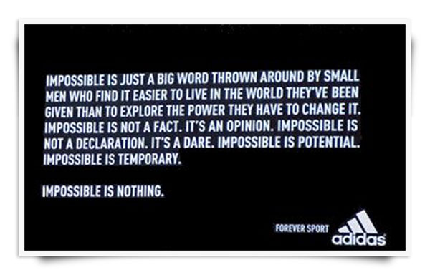
Reading Reference
First impressions matter (vi - 要緊). Love at first sight may be [Lv] a myth神話(n), but those first few moments are [Lv] vital (adj - 極其重要的, 必不可少的) when you're [Lv] out (adv) to impress. People can't help 不得不這樣做 but form an immediate opinion of you based on your appearance, your body language and the way you're [Lv] dressed, and this opinion helps (vi) to determine whether they hang (vi) around 徘徊long enough to get to know you better. (100 – 25 – 50s)
Some first impressions matter (vi) more than others, particularly when you're meeting men. One recent survey for a women's magazine found that three-quarters of men notice a woman's hair first, whereas only a handful of 少數 (adj) men mentioned clothes. That's [Lv] something to bear in mind 把...記在心 (slang - spoken style) next time you're wondering whether to spend 50 quid 【英】【俚】一鎊金幣on a haircut or a dress. (82) (20 – 40s)
Read on to find out which five things men see first when they first see you, and how this can help you in the dating game. (26)

